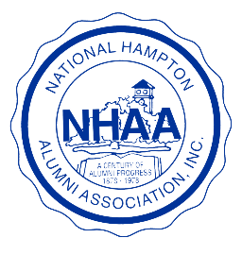

National Hampton Alumni Association, Inc.

Hampton University Hampton, Virginia 23668

NATIONAL OFFICER for 2026 - 2028 NOMINEE AGREEMENT FORM

I, of the

Chapter of the National Hampton Alumni Association (NHAA), Inc. hereby

acknowledge and accept the nomination for the office of

in the NHAA, Inc.

Signature Date

Printed Name

Address

City, State, and Zip Code

Preferred Phone Number(s)

E-mail Address

Return form to:
Derrick Lowery, Chair/Nominations Committee
296 Chippenham Lane
Hockessin, DE 19707
Email: derrick.lowery@nhaainc.org

Note:
All forms must be received, not postmarked, by the designated deadline date of October 15, 2025. This Nominee Agreement document must be sent with the Nomination Form. The application for office will not be processed without the receipt of both completed documents.

